ATP – Driver Setup Procedure

ATP – Driver setup procedure

Document version: 1.0

Release date: 4 June 2021

# Document releases

|  |  |  |
| --- | --- | --- |
| **Release date** | **Version** | **Changes** |
| June 8, 2021 | 1.0 | UK_Lane3000 Version |

# When to use this document

This document is used to setup the new payment driver in the ATP Platform.

# Destination

This document is intended for internal usage.

# Terminal Connection Setup

Before connecting the terminal make sure you have the following information from Ingenico: Terminal ID, Communication Server 1 and Communication Server 2.

**(Communication Server 1 and Communication Server 2, have now been included in the set up but still check they are correct)**

To use the terminal you need to connect it to the kiosk.

Check in device manager if the device is recognized by windows or appears in Other devices

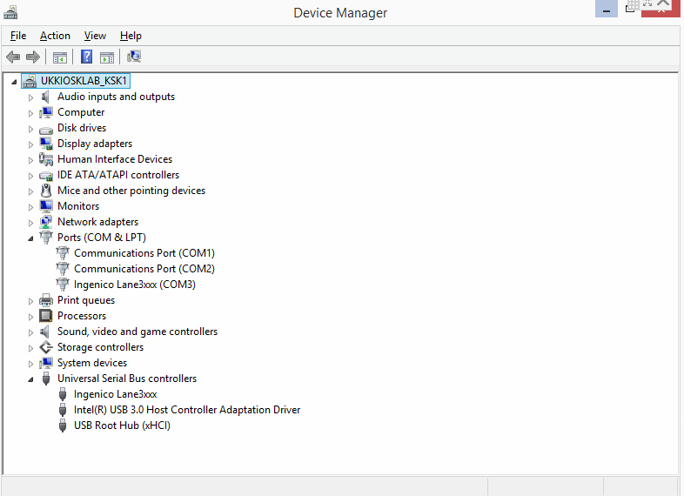

If it appears under other devices you need to install the driver located at **C:\Acrelec\Core\Peripherals\Payments\[PaymentName]\[PaymentVersion]\WindowsDriver**

For the Lane 3000 use the **IngenicoUSBDrivers_3.11_setup.exe driver.**

When installing the driver, make sure that you select the correct Ingenico terminal in this case the Ingenico Lane 3000

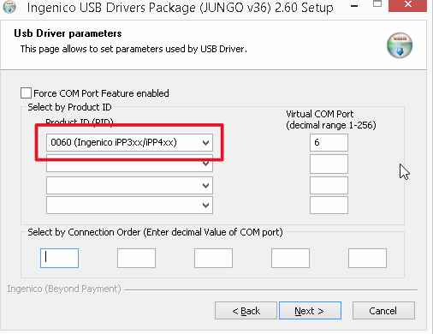

After install, a new COM port should be available in Device Manager you will use this in your set up:

Device Manager 
Eile Action Yieuu Help 
ACRELEC-VGG53g•d 
Audio inputs and outputs 
Computer 
üisk drives 
Dispiay adapters 
Human Interface Devices 
ca IDE ATA/ATAPI controllers 
Keyboards 
Mice and other pointing devices 
Monitors 
B.let,n'ork adapters 
Ports .COM & LPT) 
Communications Port (COMI) 
Sagem Telium Comm Port (COM3) 
Print queues 
Processors 
Sound, video and game controllers 
Storage controllers 
Systern devices 
Universal Serial Bus controllers 

# ATP SETUP

Open the Admin and Login.

Go to the “**Peripherals**” 🡪 select “**Payment 1**” Tab and from **Select payment** dropdown select “**UK_LANE3000”** and the latest version.

(Note. this is the PDK Studio screen which differs slightly in the Tab list)

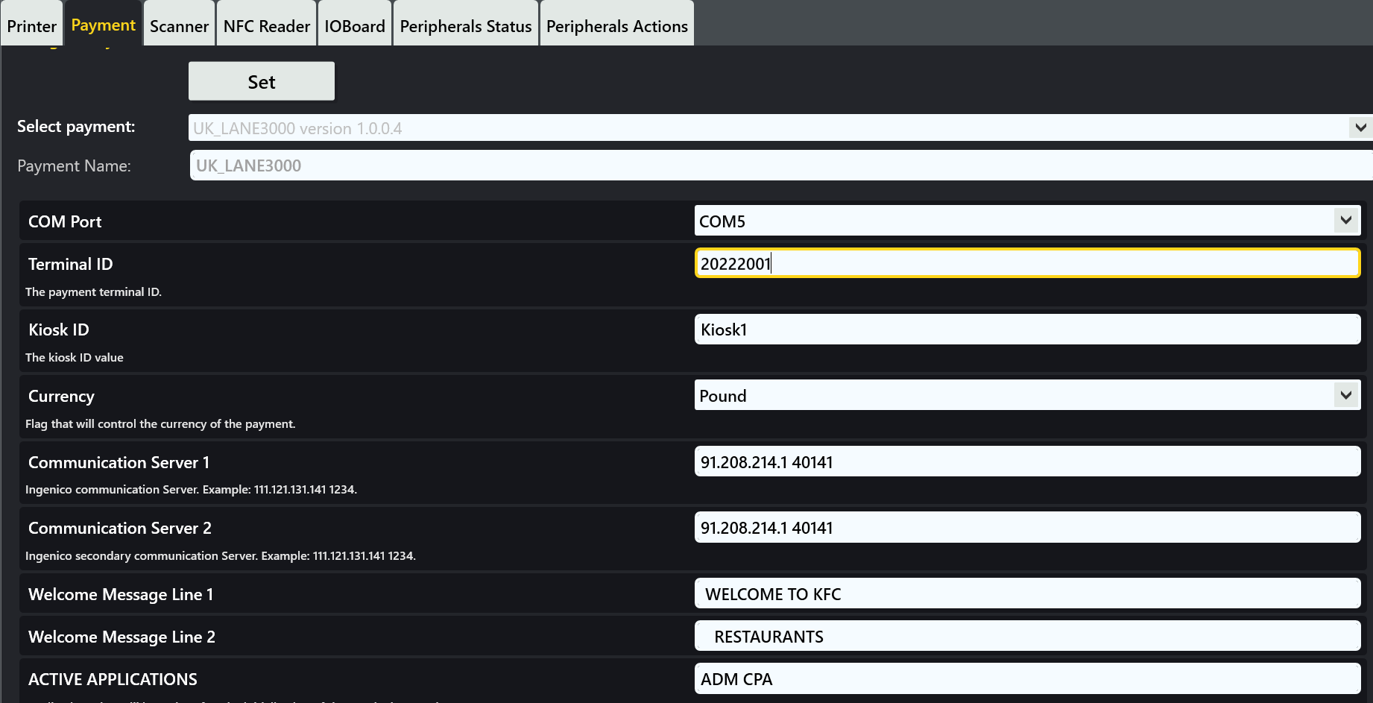

On selection of the driver the only items that aren’t prepopulated will be the

* COM Port (may be populated)
* Terminal ID.

Check the rest of the items are correct **if you are not sure of a setting contact the projects team for confirmation.** Make any changes manually if they are wrong.

**I.e** you will have to change the **KioskId** to match which Kiosk it is. **This is important as this information is required by KFC for their records as the Cashier Number.**

**COM Port** is the com port where the device is connected

**Terminal ID** should be provided by Ingenico

**Kiosk ID** is the Point of Sale Cashier Number i.e **Kiosk1, Kiosk2** ….etc

**Currency** is the used currency (i.e Euro, Pound)

**Communication Server 1** should be provided by Ingenico (has now been prepopulated)

**Communication Server 2** should be provided by Ingenico (has now been prepopulated)

**Welcome message line 1/2** message that is displayed on the terminal screen

**Active applications** are the applications that will be active after the initialization of the terminal

**TEST ENVIRONMENT SETTINGS**

When configuring the device in LAB for dev and test the following settings must be used:

**Terminal ID:** 20222001

**Communication Server 1:** 91.208.214.106 9729

**Communication Server 2:** 91.208.214.106 9729

**NOTE. These settings are NOT supposed to be used in real environments!**

After all the correct Items have been added **click Set.**

Wait for the **peripherals Tab** to go **Green** it may turn **Red** at first so wait aminute or and then it should turn **Green** if everything is OK**.**

If the tab does not go Green and stays **Red** you will need to consult the logs for your application:

**C:\Acrelec\Core\Peripherals\Payments\Drivers\UK_LANE3000\*.*.*.*\Driver\DriverExe\Logs**

In here will give you a guide as to what has gone wrong.

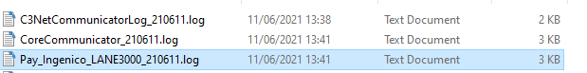

Also there are Ingenico logs in

**C:\Acrelec\Core\Peripherals\Payments\Drivers\UK_LANE3000\*.*.*.*\Driver\DriverExe\**

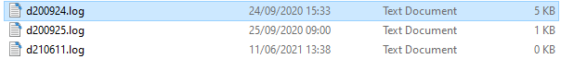

That you can send to Ingenico for further guidance.